Numerical Programs

1. Even or Odd
2. WAP to check whether the given Num is even or odd.

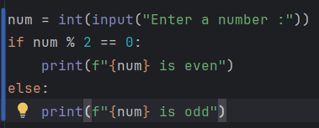

1. WAP to check whether the given Num is even or odd using customized function.

* Identify the major logic and copy
* Include a function declaration and paste the logic
* Include the parameter required by the function to perform the logic
* Design the O/P form the function
* 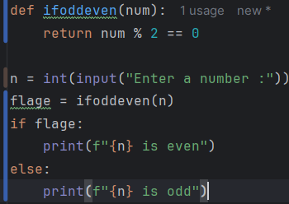Call the function and store the O/P from the function is any to reuse the O/P
* Return Num % 2 == 0 this logic return true or false using compression operator

1. WAP to print all the even Num present in user defined range

Eg:

Enter start range: 10

Enter end range: 16

Expected O/P Even Num’s :

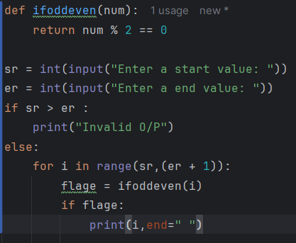 10 12 14 16

Note: In range function end value must be greater than start value

1. 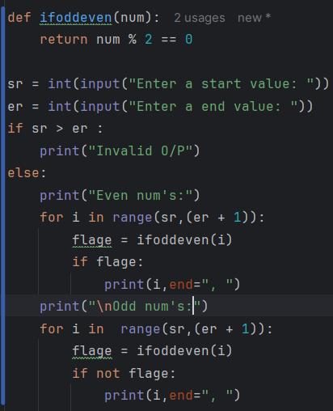WAP to print all the even and odd number’s present in the user defined range separately
2. WAP to print first n odd natural numbers

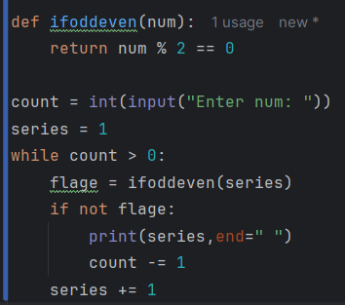

1. WAP to print first n even natural numbers

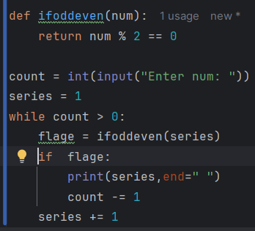

1. WAP for leap year

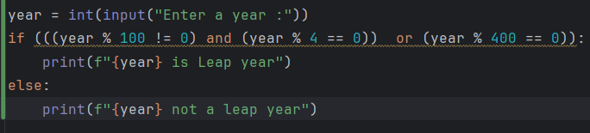

1. 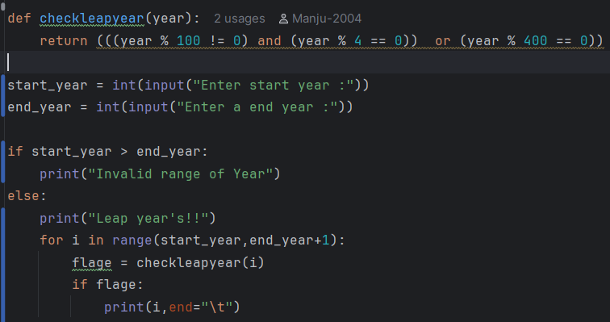WAP to print user defined range of leap year
2. 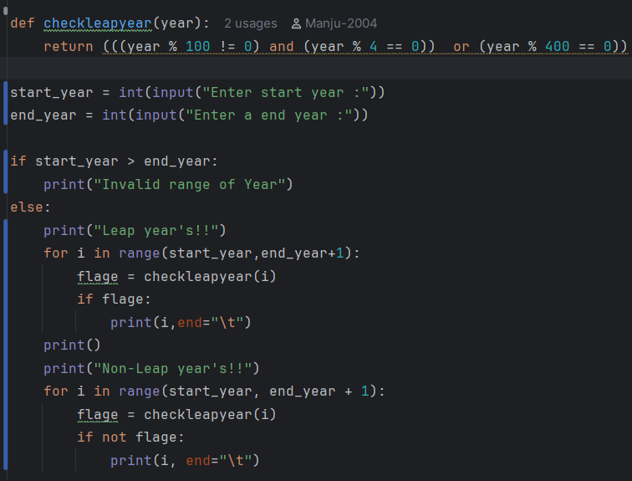WAP to print user defined range of both leap year’s and non-leap year’s

Count Degit’s

1. 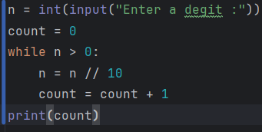WAP to count the Num’s of digits in a given number’s
2. 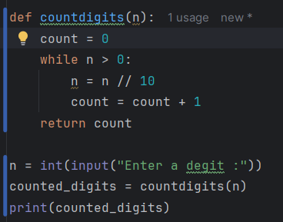using function approach

ARM strong Numbers

Note: =

* To remove digit form given number 🡺 Num // 10
* To carry forward the current cycle updated value to the next cycle for further operation and LHS for updation

1. 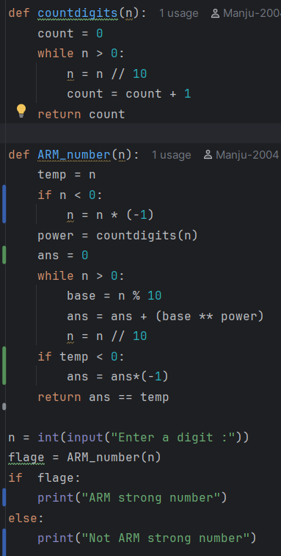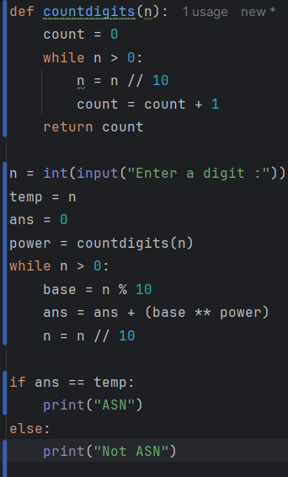WAP to print if the given number is ARM strong number or not
2. WAP to display the count of digits in each indusial numbers present in a user defined range:

I/O

Start = 9

End = 12

Excepted O/P

9 has 1 digit

10 has 2 digit’s

11 has 2 digit’s

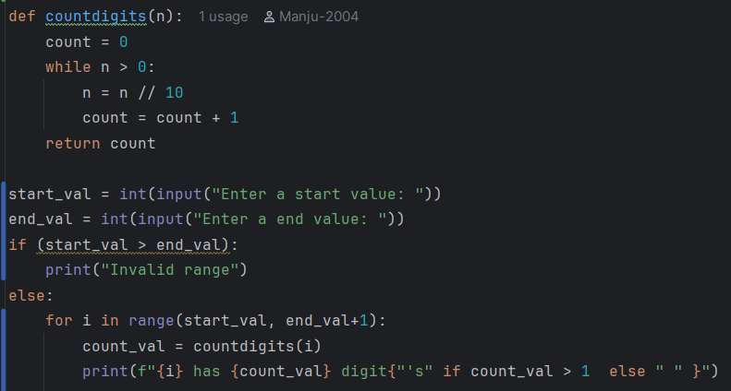 12 has 2 digit’s

1. WAP to print all the ASN’s present in user defined range

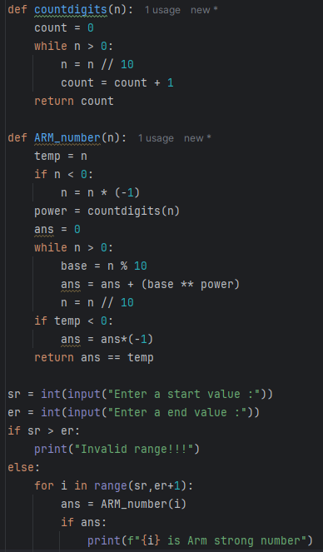

1. WAP to print all the ASN’s and non ASN’s present in user defined range separately

1. WAP to print first “n” ASN’s

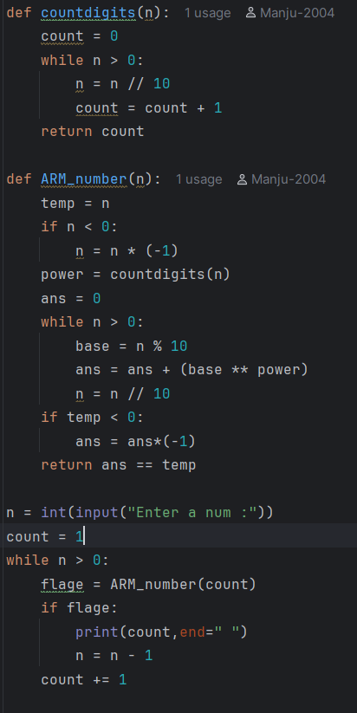

1. 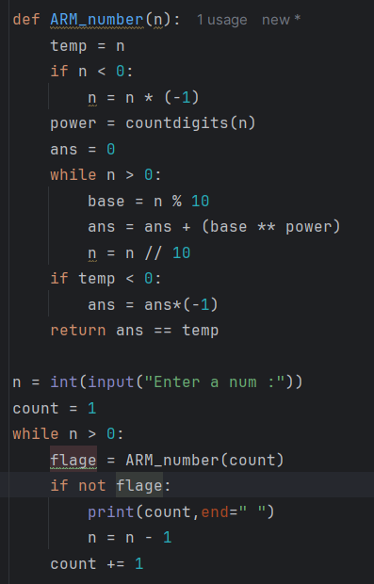WAP to print first “n” non ASN’s

REVERSE Number :

1. WAP to reverse a number.
2. 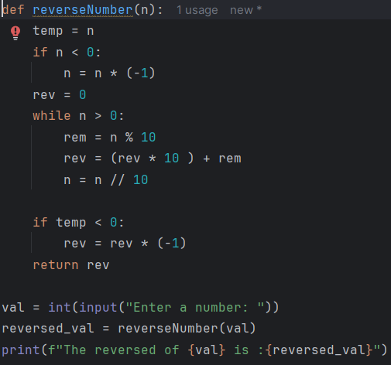WAP to print the reversal of each individual number present in user defined range

I/P:

Sr = 12 er = 14

Expected O/P:

The reversal of 12 in 21

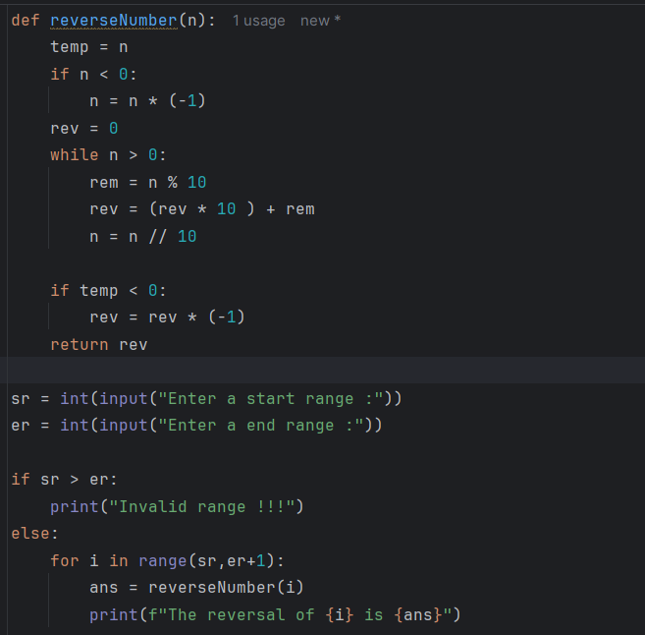The reversal of 13 in 31

INTEGER PALINDROME:

1. 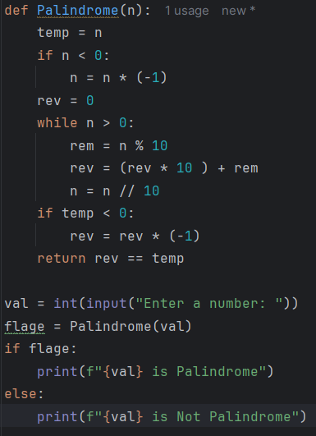IF the reversal of number is same as the original number, then it is said to be an Integer Palindrome.
2. WAP to print counting fact and counting cycle

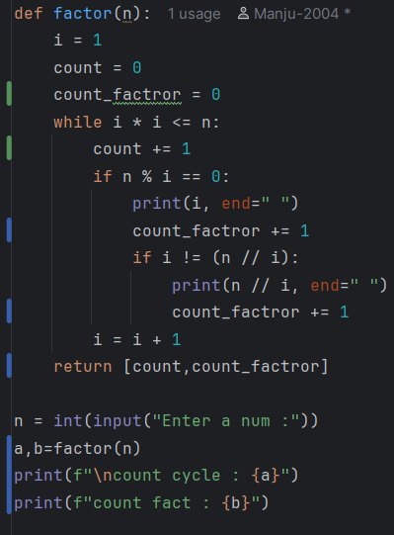

1. A screenshot of a computer program

   AI-generated content may be incorrect.WAP to check whether the given number is prime or not.
2. perfect number

1. GCD and HCF

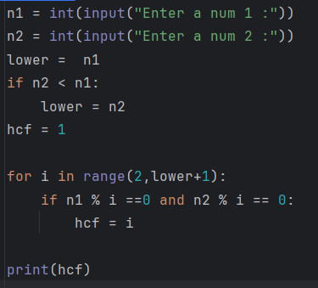

Fibonacci series

1. WAP to print Fibonacci series

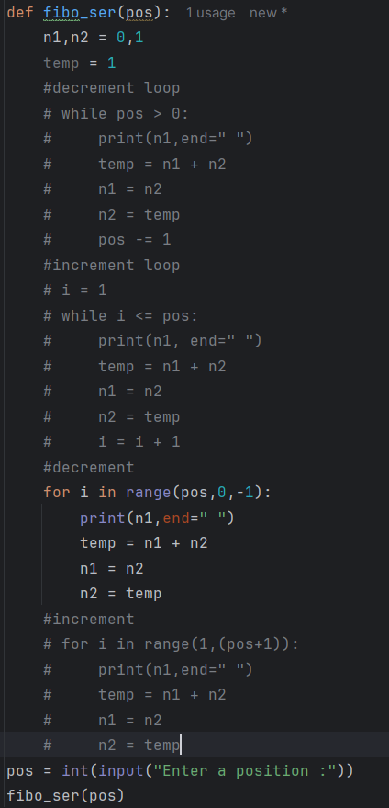

1. WAP to print LCM

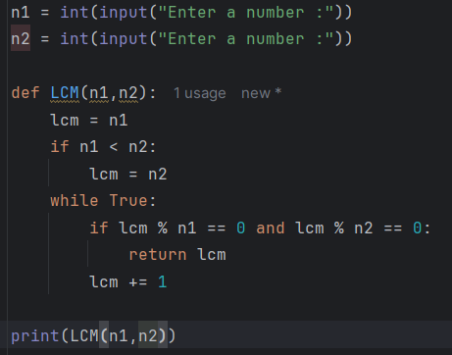

Recursion

1. 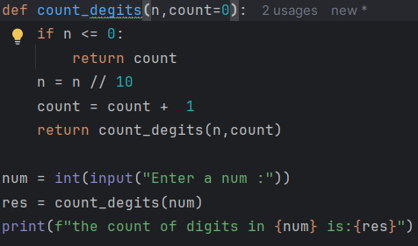WAP to count digits using rcc
2. 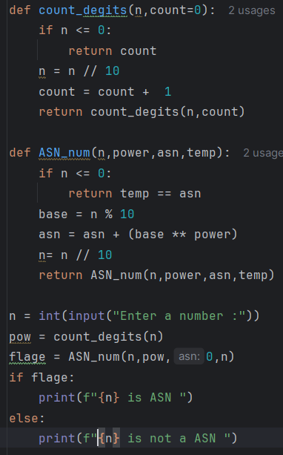ASN number using rcc_fun
3. 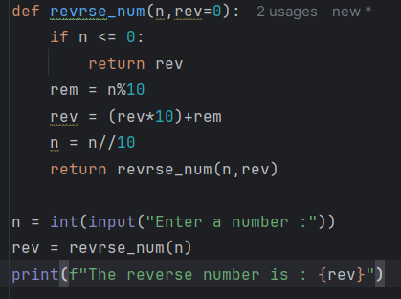WAP to reverse number using rcc
4. WAP to check the given number in palindrome

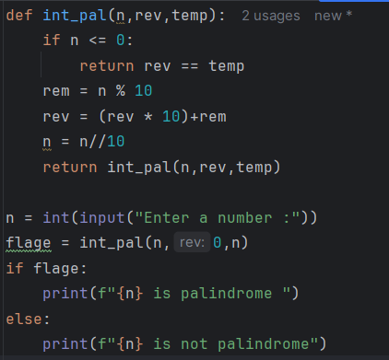

1. WAP to find factor of a number using rcc

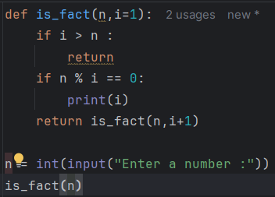

1. 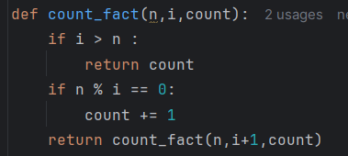WAP to print count of factor using rcc
2. 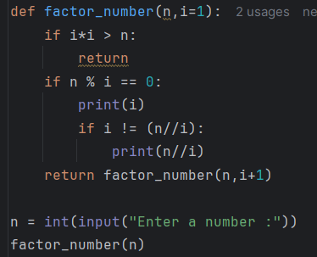WAP to print factor of number using rcc
3. 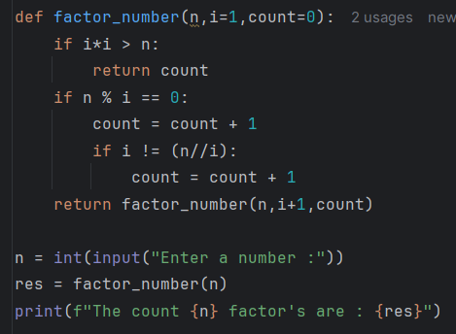WAP to print count factor of number using rcc